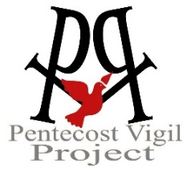
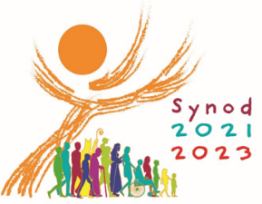
Family Interview Card: Synod 2023
The Church is Listening…
Pope Francis wants to hear from Families!
(The name of your organization/group goes here)
This Synod Interview Guide is designed to provide independent family groups
and individual families an easy way to participate in the Synod listening process.
(Complete instructions for using this Guide and submitting the results are located at the end)
Gather your family around the family table.
Use this Interview Card to share your stories, ideas and concerns
with Pope Francis and the Leaders of the Catholic Church.

Pope Francis wants to hear from All God’s People, especially children who are often over-looked.
Your comments will be shared with Church leaders in the USA, and with Pope Francis in Rome!

- How would you describe your family?
(age range, cultural background, current living situation, share anything you like).
Type or write your response here…

2. On an average day, what makes your family smile?
Type or write your response here…

3. Is church a special place for you? What are some of the things you like about church?
Type or write your response here…

4. What could be changed to make you like your church more?
Type or write your response here…

5. How can your church help you grow to know and love Jesus more?
Type or write your response here…

6. Is there anything your family would like to say to Pope Francis and Catholic leaders
in the USA and the world?
Type or write your response here…

Copy and email your completed survey to: (organization’s email goes here), no later than (deadline goes here).
How to use this Synod Interview Guide for Families
If you are an organization (any faith-based group, school, neighborhood bible study, etc.)…
- Put your organization’s name at the top. Replace the PVP logo with your organization’s logo (optional)
- After question #6, provide an email address and deadline for receiving your group’s completed surveys.
- Distribute your edited Family Synod Interview Guide to your organization’s membership via email.
- Collect the completed responses and create a group summary. (Maximum 10-page Word doc for large groups)
- Contact the U.S. Bishops at synod@usccb.org for group submission instructions (June 30 deadline).
- Or visit www.pentecostvigilproject.org or email PVPinfo@pentecostvigilproject.org for submission options.
If you are an individual family (or any very small group that wants to be heard.)…
- Complete the Interview Guide, save, and email a copy to: PVPinfo@pentecostvigilproject.org Deadline: June 10th.
- Or visit www.pentecostvigilproject.org or email PVPinfo@pentecostvigilproject.org for submission options.

