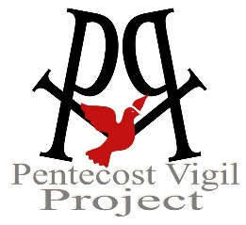
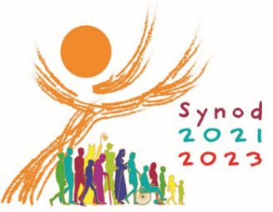
The Church is Listening…
Let Your Hopes & Dreams be Heard!

(The name of your organization/group goes here)
This Synod Interview Guide is designed to provide independent groups
and individuals the opportunity to participate in the Synod listening process.
(Complete instructions for using this Guide and submitting the results are located at the end)

Pope Francis wants to hear from All God’s People, especially those often forgotten or over-looked. Your comments will be shared with Church leadership in the USA, and with Pope Francis in Rome! Thank you for taking the time to share!

- How would you describe yourself? (age range, gender, cultural background, marriage or family, current living situation, share anything you like)
Type or write your response here…

2. On an average day, what makes you smile?
Type or write your response here…

3. On an average day, what worries you the most?
Type or write your response here…

4. Are you currently active with a church faith community?
How would you describe your personal faith life?
(active in a church, occasionally attend a church, personally spiritual but not religious, no active faith life, ex-Catholic, share anything you like)
Type or write your response here…

5. The Catholic Church is called to walk side-by-side with all of God’s Children. How can the Church do a better job of walking side-by-side with YOU?
Type or write your response here…

6. Is there anything you would like to say to Pope Francis and Catholic leadership in the USA and the world?
Type or write your response here…

Copy and email your completed survey to: (organization’s email goes here), no later than (deadline goes here).
How to use this Synod Interview Guide
If you are an organization (any faith-based group, school, health-care facility, neighborhood bible study, etc.)…
- Put your organization’s name at the top. Replace the PVP logo with your organization’s logo (optional)
- After question #6, provide an email address and deadline for receiving your group’s completed surveys.
- Distribute your edited Synod Interview Guide to your organization’s membership via email.
- Collect the completed responses and create a group summary. (Maximum 10-page Word doc for large groups)
- Contact the U.S. Bishops at synod@usccb.org for group submission instructions (June 30 deadline).
- Or visit www.pentecostvigilproject.org or email PVPinfo@pentecostvigilproject.org for submission options.
If you are an individual (or any very small group that wants to be heard.)…
- Complete the Interview Guide, save, and email a copy to: PVPinfo@pentecostvigilproject.org Deadline: June 10th.
- Or visit www.pentecostvigilproject.org or email PVPinfo@pentecostvigilproject.org for submission options.

